Services to the company’s

1. **Executive Recruitment Services**

Progressive organizations around the world are in constant search for talent. Executive Recruitment provided by staffind is the most effective way to find and place the perfect candidates for management jobs. We establish solid partnerships with our clients so as to understand their corporate cultures and needs and provide them with successful matches through a meticulous selection & assessment process.

Our database hosts tens of thousands of candidates’ profiles in all business sectors and functions. This is only one tool amongst many we deploy to source the best talent in the region.

The growing number of our satisfied clients is a testimony of our professionalism and commitment. Our distinguished team and premium recruitment have always helped us provide unparalleled levels of service.

Internally, staffind business processes, organization and work flow are all designed and geared up to provide ultimate focus on the customers' objectives and priorities.

**Executive Search Process**

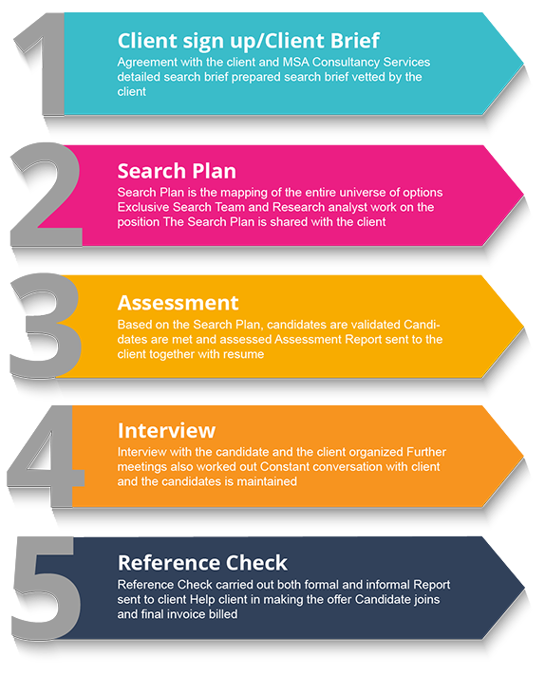

1. **Professional Resourcing**

 In today’s uncertain world, Talent overtakes capital as the key economic differentiator. Businesses must be agile enough to adapt to the ever-changing environment. We connect people with meaningful employment and employers with the best talent. As the world of work becomes increasingly complex, and talent becomes scarcer and more in-demand, our role in creating talent sustainability is ever more critical to enhancing the competitiveness of organizations and individuals. More than ever, business growth depends on putting the right people in place—the in-demand professional talent that sets your organization apart from the competition. With the deep industry knowledge, we understand the challenges your business is facing and give you access to the professional talent and expertise you need to seize new opportunity and launch your business forward.

We offer cost-effective, scalable solutions and flexible delivery models tailored to your specific objectives and organizational style. You get the degree of control you want and the expertise you need to keep your initiatives on track and your business growing. With access to one of the largest network of highly specialized Professionals, we have the experience and expertise to help you build your workforce in the way that delivers the best options for your business.

1. **Talent advisory Solution**

Are you looking to make your talent function even more effective?

Our talent advisory consultants have the solution. Drawing on all our experience of delivering talent acquisition solutions, they provide expert advice in three key areas: strategy; employer branding; and technology.

Strategy

We deliver talent acquisition solutions across entire workforces, and are expert at meeting the demands of permanent employees. We can use this experience to assess your organization’s overall talent approach, and help you develop and optimize it at a strategic level.

Employer branding

Why do people join, stay and flourish with your organization?

Our employer brand experts will find the elusive answer to that question – and help you communicate it to the audiences that matter. Their process includes research, implementation and measurement, as well as creative development. Their approach will enhance every aspect of your employer brand activity, from online advertising to employee referral schemes.

Technology

At Staffind, we aren’t tied to our own HR technologies. Instead, we focus on evaluating and testing the best the market has to offer. This gives us an in-depth understanding of the entire HR technology ecosystem, from background checking solutions to ATS. It also puts us in an ideal position to assess your organization’s talent acquisition technology, and advise you on how to optimize it.

1. **Hr for Small Business**

Established and successful small businesses have been the foundation of our model since Day 1.

With the sole purpose of improving HR within small businesses to help them reach their respective company visions. After all, when HR fully supports the operations and culture of a small business, the organization can improve and accelerate dramatically.

The services offered by staffind for small businesses allow management to focus on other strategic demands. Our goal is to meet all of your HR needs in a way that makes sense for your culture and budget. We treat your investment in us as if it were our investment. And we deliver the same high-value, high-touch level of service you provide to your customers. We are connected and passionate about how we serve our clients! Our interest is to work in your best interest.

1. **RPO**

With the competition for skilled talent intensifying, it is critical that companies adopt innovative solutions for the identification, attraction and retention of permanent staff.

These solutions must deliver visibility and control, greater access to higher quality candidates, process compliance, efficiency and cost savings.

There are several benefits from engaging in Recruitment Process Outsourcing (RPO):

* Dedicated and accountable team
* Visibility and control over all recruitment activity
* Enhanced recruitment processes and compliance
* Consistent brand promotion and candidate experience
* Effective careers site, direct hire and supplier sourcing channels
* Greater choice and enhanced quality of candidates
* Reduced HR and Manager time
* Process efficiency delivering reduced time to hire
* Controlled and reduced cost per hire
* A scalable solution that aligns with your needs

We in Staffind can be your optimum solution on RPO.